Eagle Scout Leadership Service Project Workbook

Carlos Cardenas

Scout’s name
Information Removed

Address
Information Removed

Telephone No.
777

Unit No.
Golden Eagle

District
San Gabriel Valley

Local council

Martin Cardenas

Unit leader’s name
23917 Sunset Crossing Rd. Diamond Bar, CA 91765

Address
(909)396-8653

Telephone No.

Kevin Durkee

Unit advancement committee person’s name

2516 Castle Rock Road Diamond Bar, CA 91765

Address

(909)869-7575

Telephone No.

Your Eagle Scout Leadership Service Project

How to Start

You have earned the Life Scout rank and are ready to begin your Eagle Scout leadership service project. This workbook will help you plan and record your progress and complete and submit a final report.

The Requirement

As stated in the Boy Scout Handbook: While a Life Scout, plan, develop, and give leadership to others in a service project helpful to your religious institution, school, or your community. (The project should benefit an organization other than the BSA.) The project plan must be approved by the organization benefiting from the effort, your unit leader (Scoutmaster, Varsity Scout Coach, Venturing crew Advisor), unit committee, and by the council or district advancement committee before you start. You must use this Eagle Scout Leadership Service Project Workbook, No. 18-927D, in meeting this requirement.

Originality

Does the leadership service project for Eagle have to be original, perhaps something you dream up that has never been done before? The answer: No, but it certainly could be. You may pick a project that has been done before, but you must accept responsibility for planning, directing, and following through to its successful completion.

Limitations

Routine labor (a job or service normally rendered) should not be considered. Work involving council property or other BSA activity is not permitted. The project also may not be performed for a business or an individual, be of a commercial nature, or be a fund-raiser. (Fund-raising is permitted only for securing materials or supplies needed to carry out your project.)

Size

How big a project is required? There are no specific requirements, as long as the project is helpful to a religious institution, school, or community. The amount of time spent by you in planning your project and the actual working time spent in carrying out the project should be as much as is necessary for you to demonstrate your leadership of others.

Examples

A look at some projects other Scouts have done for their Eagle Scout Award illustrates that your project can be to construct something or can be to render a service. Scouts have
- Made trays to fasten to wheelchairs for veterans with disabilities at a Veterans Administration hospital.
- Collected used books and distributed them to people in the community who wanted and needed, but could not afford, books.
- Built a sturdy footbridge across a brook to make a safe shortcut for children between their homes and school.
- Collected and repaired used toys and gave them to a home for children with disabilities.
- Organized and operated a bicycle safety campaign. This involved a written safety test, equipment safety check, and a skills contest in a bike rodeo.
- Surveyed the remains of an old Spanish mission and prepared an accurate map relating it to the present church.
- Built a “tot lot” in a big city neighborhood and set up a schedule for Boy Scouts to help run it.
- Set up a community study center for children who needed a place to do schoolwork.
- Trained fellow students as audiovisual aides for their school. Arranged for more than 200 hours of audiovisual work.
- Prepared plans for a footbridge on a trail in a national forest. Worked with rangers to learn the skills necessary to build the structure, gathered materials and tools, and then directed a Scout work group to do the construction.

Approvals

Before You Start

Your project plan must be approved by your unit leader, unit committee, and council or district advancement committee before the project is started. The following questions must be answered before giving this approval:
- Who will benefit from the project?
- How will they benefit?
- What official from the group benefiting from the project will be contacted for guidance in planning the project?
- How many people will be recruited to help carry out the project?

Remember, the project must be approved before you begin, so make sure all signatures have been secured before you start the project. You must be a Life Scout before you begin an Eagle Scout leadership service project.

After Completion

Although your project was approved by your unit leader, unit committee, and council or district advancement committee before it was begun, the Eagle Scout board of review must approve the manner in which it was carried out. The following must be answered:
- In what ways did you demonstrate leadership of others?
- Give examples of how you directed the project rather than doing the work yourself.
- In what way did the religious institution, school, or community group benefit from the project?
- Did the project follow the plan?
- If changes to the plan were made, explain why the changes were necessary.

Filling Out the Form

As you plan and carry out your leadership service project, use this workbook to record your plans and progress. Remember that others will be reading these pages. You should print, type, or write legibly using black or blue ink. Complete the form on a computer if you have access to an electronic version. You may add as many pages as needed to thoroughly complete the workbook.

National Eagle Scout Association

The National Eagle Scout Association was created in 1972 with the express purpose of bringing together Eagle Scouts of all ages so that they may be of greater service to themselves, their local councils, and their communities, thereby conserving and developing the human resources potential represented by those who hold Scouting’s highest rank.

When you receive your Eagle badge, you will be eligible for membership in this elite association. You should give it serious consideration. Applications are available from your local council service center.

Project Description

Describe the project you plan to do.

I plan to do my Eagle Project at Suzanne Middle School in the city of Walnut.

At the north side of the main entrance of the school is a bare hill that needs to be re-landscaped. The total project consists of two sections. The first section is a mostly bare area of approximately 1325 ft². The second section adjoins with the first area, and is currently covered by Apple Cherry groundcover with an area of approximately 969 ft². I will be removing this current groundcover and re-landscaping this area as well.

My project will involve redoing the landscape as well as fixing an irrigation problem which allows excessive water runoff when the sprinklers are turned on. I will show leadership by leading a group of scouts in re-landscaping this hill and by showing them proper techniques to be used while working on this hill.

I chose this project because it involved school beautification and water conservation. I also chose to do a project at this school because my sister is currently attending this school and I wanted to give back to the school for the help they have given to her.

What group will benefit from the project?

Suzanne Middle School (909)594-1657

Name of religious institution, school, or community Telephone No.

525 Suzanne Rd. Walnut CA 91789

Street address City State Zip code

My project will be of benefit to the group because:

By fixing the irrigation problem, the school will conserve water.

Re-landscaping the hill will reflect positively of the school. This existing groundcover strongly attracts bees. By removing this groundcover, it will prevent the students being stung by the bees. By re-landscaping this hill, not only will it reflect positively to the students but it will also reflect greatly to the community.

My project will also be of benefit to the scouts because I will help them live up to the Scout Slogan, Do a Good Turn Daily. It will also help them earn experience with garden work and using gardening tools. It will also reflect positively on scouting to the community.

This concept was discussed with my unit leader on: | 1/27/08  Date

The project concept was discussed with the following representative of the group that will benefit from the project.

 | Les Ojeda  Representative’s name | 10/4/07  Date of meeting
 | Interim Principal  Representative’s title | (909)594-1657 Ext.55202  Phone No.

Project Details

Plan your work by describing the present condition, the method, materials to be used, project helpers, and a time schedule for carrying out the project. Describe any safety hazards you might face, and explain how you will ensure the safety of those carrying out the project.

1. Present Condition
The majority of the hill is very bare and about 1325 ft², which has slight slope, contains almost nothing. About 969 ft² of the ground has Cherry Apple ground cover which attracts bees. On the bare hill there are only 2 Crape Myrtle trees, 1 palm tree, 10 sprinklers, and 1 rose bush. At the request of the school the rose bush and the Apple Cherry groundcover will be removed.

The hill is bordered by a railing on one side and by a 2 inch retaining wall on the other side that extends about 100 ft. These two borders do not meet which leaves a gap of ~1.5 ft. When the sprinklers go off, some of the water runs out through the gap and causes dirt and debris to clutter the sidewalk. (See the picures and map attached as Appendices A and B).

A. Method Overview

1. Determining what plants and materials are going to be used and total cost.

I contacted the Vice Principal of Suzanne Middle School and discussed my plans with him about re-landscaping the hill. He accepted to my idea and then redirected me to the schools grounds person, Gene Kennebrew. Gene talked to his boss and the school decided that they would provide all the different plants and woodchips necessary (see material list) to do the project. The new plants include 1 palm tree, flax, garlic society, and fountain grass. A couple of weeks later I went to a local Home Depot and researched the costs of the different plants and the different needs that needed to be satisfied for each plant (see Appendix C for a price chart). From looking at the situation I deduced the various gardening materials needed such as hoes and shovels for re-landscaping the hill.

2. Financing

At first I figured out the total cost of plants and materials. I thought of ways to fundraise for my project. I could go around to different organizations and my troop for monetary donations. If I still don’t’ have enough money, I could plan a carwash at one of the local fast food restaurants. I could also ask the school to donate the plants and materials necessary to redo the hill. For the gardening tools, I could ask the adults in the troop if they can lend me any tools they may possibly have. Then I met with Gene Kennebrew, the school groundsperson, and they decided to donate 1 palm tree, flax, garlic society, and fountain grass (see attached letter of donation).

B. Carrying out the Project

1. Project Time Line

8:00- My dad and I will arrive at the school site and prepare the site for the project such as setting up tables and putting out the morning snacks. We will also mark all the sprinklers with a piece of tape.

8:20- The scouts will arrive at the school and I will greet them and let them know that they will need to sign in and leave any tools they brought with me. I will then organize all the tools and make sure they are ready for use.

8:30- While the scouts are eating I will give them a summary of all the work that will be done throughout the day. I will then review with them the safety precautions that must be taken into consideration while working. I will also warn them about the marked sprinklers that are around the area and that they need to be careful about where they are digging. Then I will show them where the restrooms are.

8:40- I will then divide the scouts into 2 different groups. The majority of the scouts will go into the first group. This group will be in charge of pulling out the groundcover on the right half of the hill. The second group will consist of about 2 older scouts. This group will take out the old rose bush in the upper left corner of the hill. When the second group is done they will construct the wood forms for the cement and then mix the cement and water with a shovel in a wheel barrow. They will then place two pieces of wood to hold the cement together in the small gap of the hill. If they finish early then they will join the other scouts in pulling out the ground cover. As the scouts are working on the hill I will show leadership by following their progress in their work, solving any problems that may arise, and give encouragement as needed. While the project is going, I will have a 3 deep leadership for overseeing the scout’s safety during the project.

10:00- At this point, I will allow the scouts to take a 10 minute break to rest and rehydrate. While they are doing this I will give a quick plan as to what they should do next.

10:10- I will ask the scouts to resume working on the hill. I will ask a group of about 5-6 scouts to grab trash bags and start to pick up all of the removed ground cover and dispose of them in a nearby trash bin (I checked with the custodians and have permission to use the trash bins). I will also make sure that the scouts are removing the groundcover with the roots.

10:35- By this time, the scouts should be done pulling out the groundcover on the hill. I will then show them where I want the new plants to be planted. The plants will be laid out in the exact place I want them to be planted to clear up any placement issues. I will also show them how deep the hole should be for each plant. I will assign the younger scouts to do the smaller plants. I will let the older scouts plant the heavier plants such as the palm tree and bigger bushes.

12:00- I will ask the scouts to take a lunch break at this point. My parents have told me that they will provide the lunch.

12:35- I will ask the scouts to resume working on the hill. The scouts should be close to finished in planting the plants by this time. I will then ask a group of 6-7 scouts to start shoveling piles of woodchips onto the hill. When the other scouts are done planting they will join with the other scouts by spreading the woodchips out evenly throughout the hill. I will ask the 2 of the older scouts to make sure that the low voltage visible conduit is covered up and to make sure the sprinkler boxes do not get covered up in woodchips.

1:40- By this time, the scouts should be done with everything. I will make a final inspection to make sure that everything was done correctly and properly. It is in this time that the scouts will sweep any debris in the area. I will ask the scouts to do a final trash sweep.

2:00- When they are done cleaning up I will dismiss the scouts and thank them for coming to help me with my Eagle project.

C. Additional Project Details

Recruiting helpers for the project:
I will recruit helpers from within Troop 777 which will include any and all adults and scouts. I will need at least 20 scouts at my project. About 3 weeks before my project I will attend my weekly troop meeting and make an announcement about my Eagle project and I will also ask for people to donate their tools for the day. I will also pass out flyers at the meeting. At each troop meeting I will be responsible for having a sign up sheet for the various materials and tools I will need for my project. I will continue this process every week up until my project. Two nights before my project, I will call everyone on my sign up sheet and remind them to about my Eagle project.

I will individually talk to some of the older scouts and adults at the meeting to assure myself that I will have responsible and older scouts that can handle the cement and planting the palm tree.

Transportation:
The scouts will find their own method of transportations to the school site. In the case that someone needs a ride to my project; I will arrange a carpool for them.

Adult Supervision
According to the Boy Scout policies, there needs to be a minimum 3 deep leadership at my project. The three adult leaders will be my dad, which is the scoutmaster, and my Eagle advisor, Mr. Soikkeli who is a teacher at Suzanne, and one of the other troop adults.

Food and Refreshments
My family has decided to cover all the costs under the food aspect of my Eagle Project. They will be purchasing Pizza from Costco for lunch. I will be buying already made muffins, fruit, and orange juice for the morning time. For snacks throughout the day, I will buy granola bars and water bottles. For lunch I will have chips, boxed juices, cookies, and pizza. Under this budget they will also purchase paper plates, plastic utensils, and napkins. In the morning,

After Project:
After the project I will write thank you letters to every scout and adult that helped on my project. I will also write a thank you letter to the school for donating all the plants to me and also for allowing me to do my project at their school.

D. Safety
I need to make sure that the workers have gloves so they don’t hurt their hands. I also need to remind them about not fooling around and being careful when they have tools in their hands. I also need to inform them and supervise them when they are close to the sprinklers pipes and the conduit. About a week before my project I will tell everyone to wear loose fitting jeans, shirts, hats, and working gloves to prevent heat and injury on their body. I will tell them to make sure to lean their tools up against a wall rather than on the floor so no one will hit themselves. I will have gloves for the people who will be working with the cement. The sprinkler wires are low voltage so there is no danger. I will also have the troop’s first aid kit with me so if there is ever an accident I am ready to treat it. I will also have a copy of the troop’s roster available in case of an emergency.

Labor Estimate
For Myself

Task | Hours
Meet with school representative | 2
Take “before” pictures | 1
Write up project plans | 15
Present to Troop and Council | 1
Make fliers and distribute at the meetings | 2
Gathering and organizing all materials (gardening tools, food, etc.) | 3
Do Eagle project | 6.5
Take “after” pictures | 0.5
Write the final report | 2
Write Thank You letters | 1.5
Total Hours | 34.5

For my Helpers
Task | Helpers(out of 20) | Hours | Total
Remove ground cover | 16 | 2
Remove rose bush | 2 | 0.5
Lunch | 20 | 1
Dig holes for all new plants | 16 | 1.5
Mix cement and set it in place | 4 | 1
Plant all plants and spread out the woodchips | 20 | 2
Clean Up | 20 | 1
Total | 20 | 8.4 | 168 hours

List of Materials I Need to Buy
(none)

List of Tools and Supplies
- 4 Big shovels
- 2 Wheelbarrow
- 10 hand held shovels
- 6 steel rakes
- 1 pair of tree clippers
- 2 small rectangular pieces of wood
- 5 Hoes
- 1 box of black trash bags
- 1 roll of blue tape
- 2 pairs of leather gloves
- Water hose with key valve
- Tub for mixing cement
- 2 Brooms
- 1 scraper to scrape of cement splashes
- 1 marker

Project Finances
The school will be able to donate all of the plants and woodchips needed to redo the hill. My family said that they would cover the costs of all food aspects in my project. The various adults and scouts will be able to bring their own gardening materials such as rakes and shovels. I will bring a roll of tape and a marker for labeling each tool and who they belong to. The wood and cement will be donated by my scoutmaster since he has extra wood and cement at his home.
If appropriate, include photographs of the area before you begin your project. Providing before-and-after photographs of your project area can give a clear example of your effort.

Appendix A

“Before” Photographs
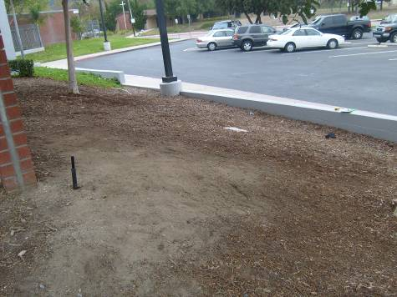
Ground on the left side of the hill is bare and empty.
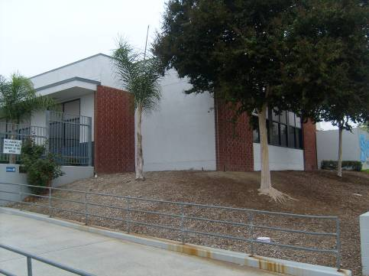

Complete left side of the hill. There is a palm tee in the upper left corner of the picture.

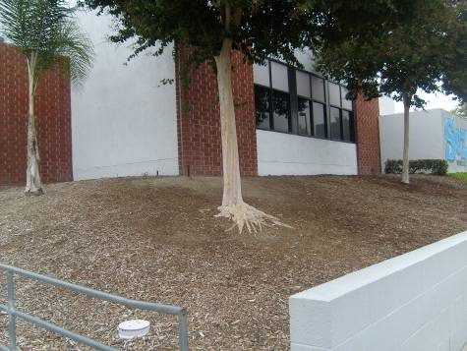
Close up on the left side of the hill.

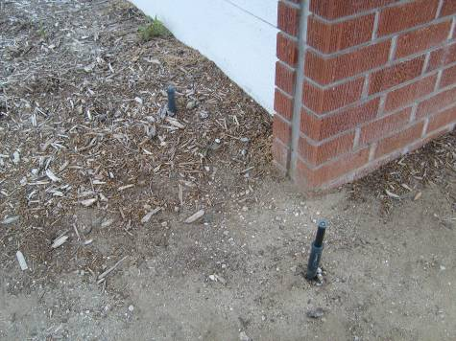
This is one of the many sprinklers on the hill.

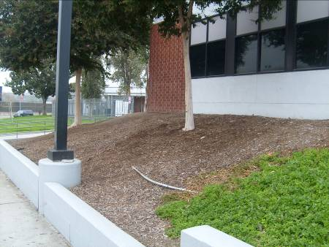
You can see the lamp post and part of the conduit in the floor.

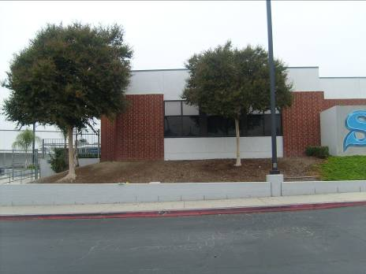

Both of the Crape Myrtle trees. General view of the left side of the hill.

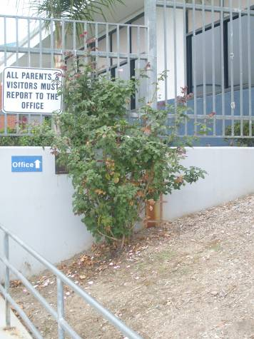
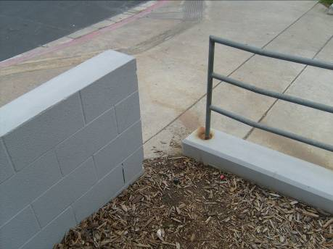
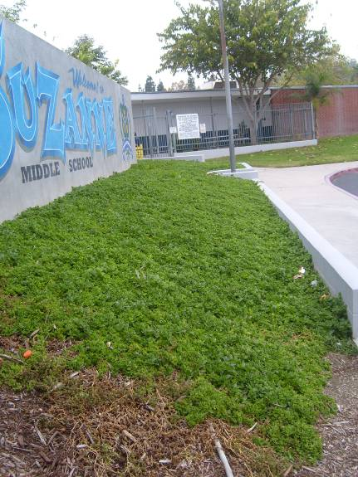
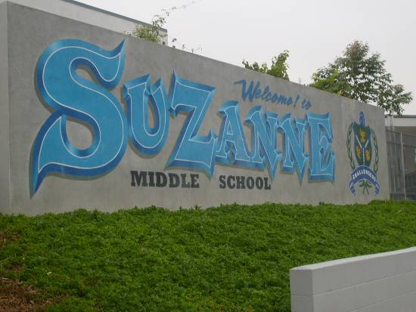
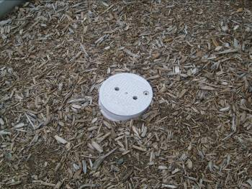
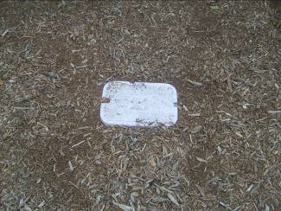
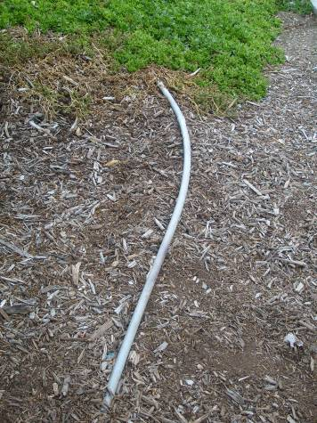
Appendix B
This is the dry rose bush that has to be removed at the request of the school.
Small gap on the corner of the hill where water escapes.
This is the whole right side of the hill that has Apple Cherry groundcover. This groundcover will be removed at the request of the school.
This is the school mural with the Apple Cherry groundcover below it.
This is the sprinklers control box. It is low voltage.
This is one of the water valves that are on the hill.
This is the conduit that is visible on the hill.
Project Map
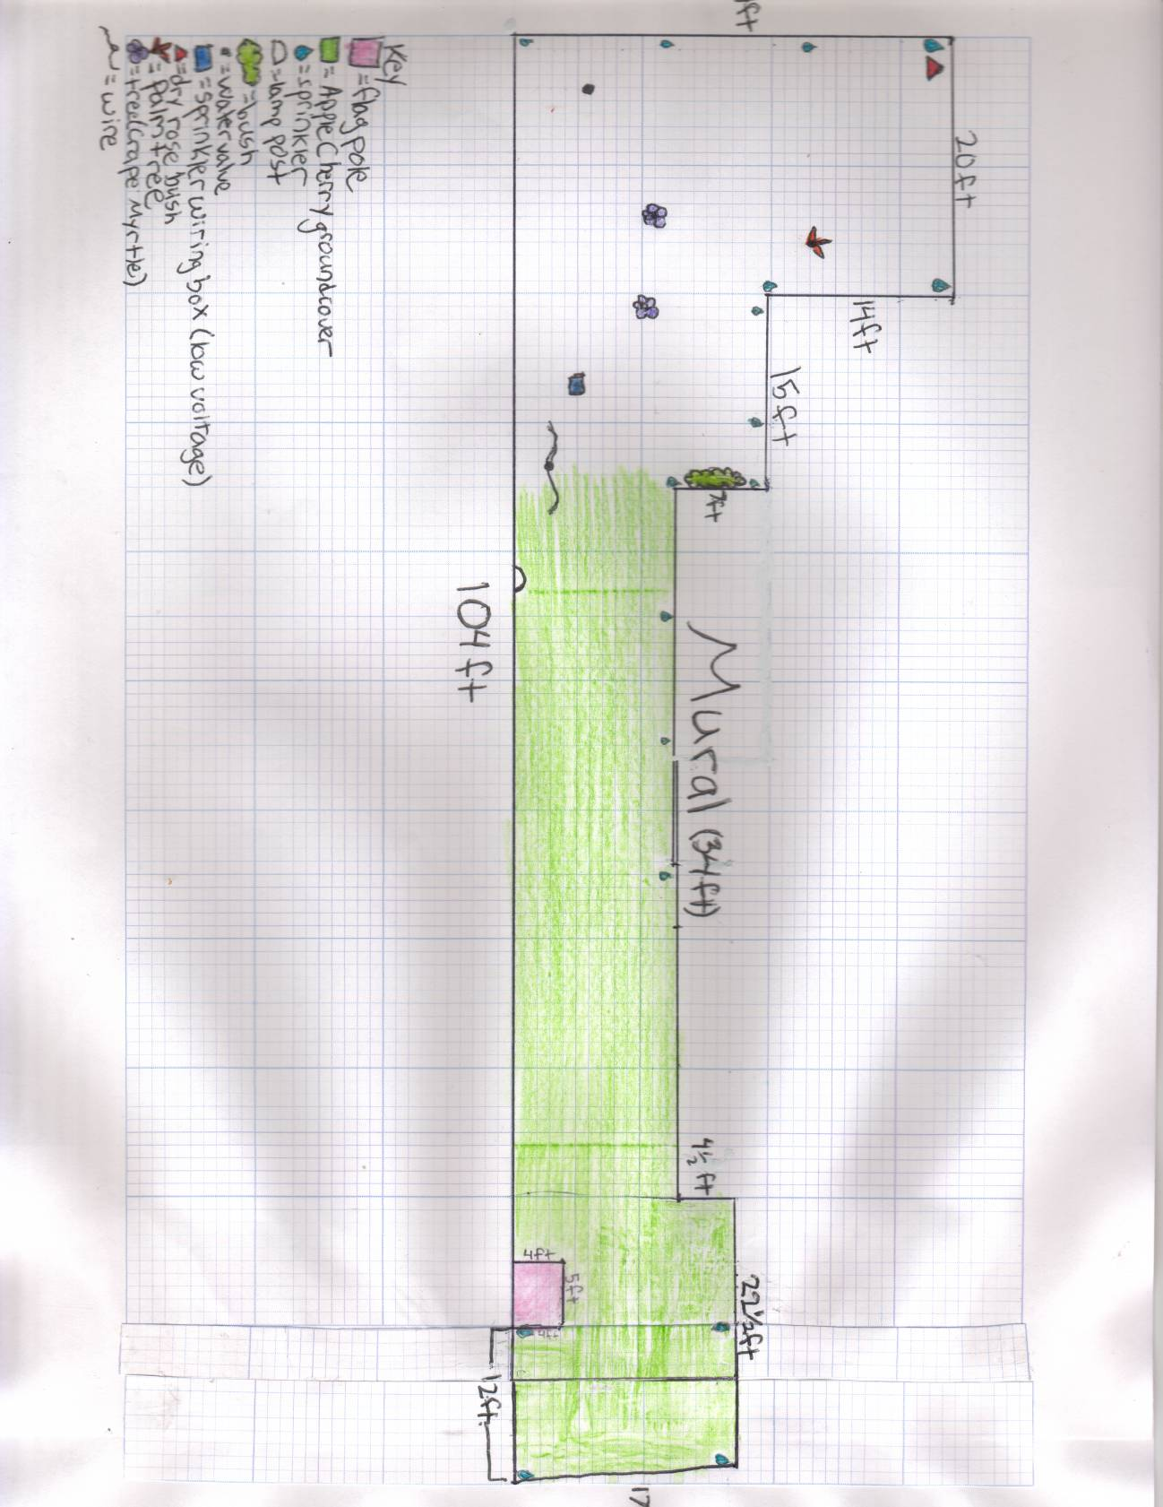
Appendix C
Materials Required to Complete the Project

Type of Material | Cost of Material | Provided by
Fountain Grass 15 x $5.97 | $89.55 | School
Garlic Society 15 x $4.47 | $67.05 | School
Flax 36 x $6.47 | $232.92 | School
Palm Tree (Queen Palm) 1 x $49.97 | $49.97 | School
Pizza | $50 | Parents
Snacks | $40 | Parents
Drinks | $50 | Parents
Roll of Tape and marker | -- | Myself
4 Shovels | -- | Parents and leaders
2 Wheelbarrows | -- | Parents and leaders
10 hand held shovels | -- | Parents and leaders
6 steel rakes | -- | Parents and leaders
1 pair of tree clippers | -- | Parents
2 small pieces of wood | -- | Parents
5 hoes | -- | Parents and leaders
1 box of trash bags | -- | Parents
2 pairs of leather gloves |  | Parents and leaders
Water hose with key valve | -- | School
Tub for mixing cement |  | Leaders
2 Brooms | -- | Parents and leaders
1 Scraper | -- | Myself
Total Cost | $579.94

Appendix D
Donation Letter from Suzanne Middle Scholl
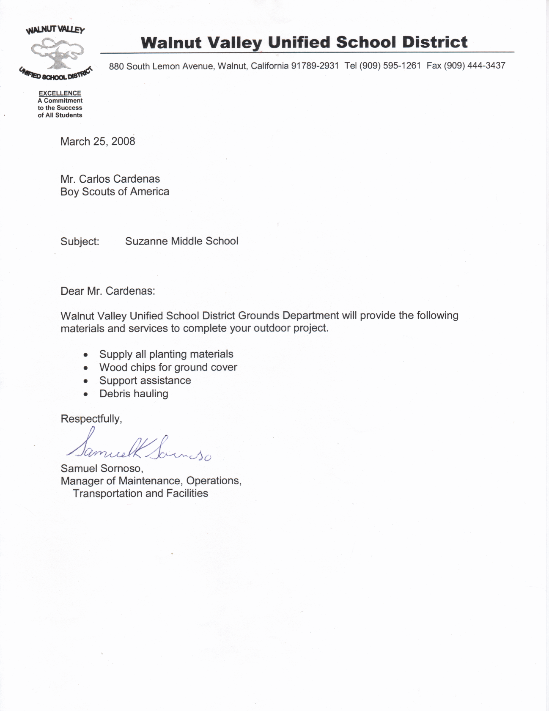

Approval Signatures for Project Plan

Project plans were reviewed and approved by:
Religious institution, school, or community representative Date | Scoutmaster/Coach/Advisor Date
Unit committee member Date | Council or district advancement committee member Date

Important Note: You may proceed with your leadership service project only when you have:
Completed all the above mentioned planning details
Shared the project plans with the appropriate persons
Obtained approval from the appropriate persons
Carrying Out the Project

Record the progress of your project. Keep a record of how much time you spend planning and carrying out the project. List who besides yourself worked on the project, the days they worked, the number of hours they worked each day, and the total length of time others assisted on the project.

If appropriate, list the type and cost of any materials required to complete the project. If your original project plan changes at any time, be sure to document what the change was and the reason for the change.

Hours I Spent Working on the Project

The length of time spent should be as adequate as is necessary for you to demonstrate your leadership of two or more individuals in planning and carrying out your project.

Hours I spent:

Planning the project:
Carrying out the project:
Total hours I spent working on the project:

Hours Spent by Scouts, Venturers, or Other Individuals Working on the Project

Name | Date (mm/dd/yy) | No. of Hours

Total number of hours others worked on the project: _____________

For a grand total, add the total number of hours you spent on the project to the total number of hours others worked on the project: ______________

Changes

List any changes made to the original project plan and explain why those changes were made.

(This box may be adjusted to fit your description.)
“After” Photographs

Including photographs of your completed project (along with the “before” photographs) helps present a clearer overall understanding of your effort.

Approvals for Completed Project

Start date of project: Completion date of project :

The project was started and has been completed since I received the Life Scout rank, and is respectfully submitted for consideration.
Applicant's signature | Date

This project was planned, developed, and carried out by the candidate.
Signature of Scoutmaster/Coach/Advisor | Date
Signature of the representative of religious institution, school, or community | Date
The 12 Steps From Life to Eagle

The following 12 steps have been outlined to ensure a smooth procedure for the Scout, the unit leadership, the local council, and the volunteers who are to conduct the board of review. Eagle candidates should share these steps with their unit leader so that they can fully understand the procedures that must be followed.

- In order to advance to the rank of Eagle, a candidate must complete all requirements of tenure; Scout spirit; merit badges; positions of responsibility; while a Life Scout, plan, develop, and provide leadership to others in a service project; and the Scoutmaster conference.

- Using the Eagle Scout Leadership Service Project Workbook, the candidate must select his Eagle service project and have the project concept approved by his unit leader, his unit committee, and the benefactor of the project, and reviewed and approved by the council or district advancement committee. This workbook must be used in meeting this requirement.

- It is imperative that all requirements for the Eagle Scout rank except the board of review be completed prior to the candidate’s 18th birthday. When all requirements except the board of review for the rank of Eagle, including the leadership service project, have been completed, the Eagle Scout Rank Application must be completed and sent to the council service center promptly. (Youth members with disabilities should meet with their unit leader regarding time extensions.)

- The application should be signed by the unit leader at the proper place. The unit committee reviews and approves the record of the Eagle candidate before the application is submitted to the local council. If a unit leader or unit committee fails to sign or otherwise approve an application, the Eagle candidate may still be granted a board of review. The failure of a unit leader or unit committee to sign an application may be considered by the board of review in determining the qualification of the Eagle candidate.

- When the completed application is received at the council service center, its contents will be verified and the references contacted. The council advancement committee or its designee contacts the person listed as a reference on the Eagle Scout Rank Application either by letter, form, or telephone checklist. The council determines the method or methods to be used. The candidate should have contacted those individuals listed as references before including their names on the application. The candidates should not be involved personally in transmitting any correspondence between persons listed as references and the council service center.

- The Eagle Scout Leadership Service Project Workbook, properly filled out, must be submitted with the application.

- After the contents of an application have been verified and appropriately signed, the application, Eagle Scout Leadership Service Project Workbook, and references will be returned from the council service center to the chairman of the Eagle board of review so that a board of review may be scheduled. Under no circumstances should a board of review be scheduled until the application is returned to the chairman of the Eagle board of review. Reference checks that are forwarded with the application are confidential, and their contents are not to be disclosed to any person who is not a member of the board of review.

- The board of review for an Eagle candidate is composed of at least three but not more than six members. One member serves as chairman. Unit leaders, assistant unit leaders, relatives, or guardians may not serve as members of a Scout’s board of review. The board of review members should convene at least 30 minutes before the candidate appears in order to review the application, reference checks, and leadership service project report. At least one district or council advancement representative must be a member of the Eagle board of review if the board of review is conducted on a unit level. A council or district may designate more than one person to serve as a member of Eagle boards of review when requested to do so by the unit. It is not required that these persons be members of the advancement committee; however, they must have an understanding of the importance of the Eagle board of review.

- The candidate’s unit leader introduces him to the members of the board of review. The unit leader may remain in the room, but does not participate in the board of review. The unit leader may be called on to clarify a point in question. In no case should a relative or guardian of the candidate attend the review, even as a unit leader. There is no set of questions that an Eagle candidate should be asked. However, the board should be assured of the candidate’s participation in the program. This is the highest award that a Scout may achieve and, consequently, a thorough discussion of his successes and experiences in Scouting should be considered. After the review, the candidate and his unit leader leave the room while the board members discuss the acceptability of the candidate as an Eagle Scout. The decision must be unanimous. If the candidate meets the requirements, he is asked to return and is informed that he will receive the board’s recommendation for the Eagle Scout rank. If the candidate does not meet the requirements, he is asked to return and told the reasons for his failure to qualify. A discussion should be held with him as to how he may meet the requirements within a given period. Should the applicant disagree with the decision, the appeal procedures should be explained to him. A follow-up letter must be sent to the Scout confirming the agreements reached on the action(s) necessary for the advancement. If the Scout chooses to appeal, the board should provide the name and address of the person he is to contact. (See ‘‘Appealing a Decision” in the National BSA Policies and Procedures, No. 33088D.)

- Immediately after the board of review and after the application has been appropriately signed, the application, the service project report, references, and a properly completed Advancement Report are returned to the council service center.

- When the application arrives at the council service center, the Scout executive signs it to certify that the proper procedure has been followed and that the board of review has recommended the candidate for the Eagle Scout rank. This workbook and references are retained by the council. The workbook may be returned to the Scout after council approval.
Only the Eagle Scout Rank Application is forwarded to the national Eagle Scout Service.

- The Eagle Scout Service screens the application to ascertain information such as proper signature, positions of responsibility, tenure between ranks, and age of the candidate. Any item not meeting national standards will cause the application to be returned for more information. If the application is in order, the Scout is then certified as an Eagle Scout by the Eagle Scout Service on behalf of the National Council. Notice of approval is given by sending the Eagle Scout certificate to the local council. The date used on the certificate will be the date of the board of review. The Eagle Award must not be sold or given to any unit until after the certificate is received by the council service center. The Eagle Scout court of honor should not be scheduled until the local council receives the Eagle Scout rank credentials.

18-936
2006 Boy Scouts of America

