# Eagle Scout Leadership Service Project Workbook

|  |  |
| --- | --- |
| EagleMedal_BW | Scout’s name  Howard Kuo  Address  **Information Removed**  Telephone No.  **Information Removed**  Unit No.  Troop 777  District  Golden Eagle  Local council  San Gabriel Valley Council Unit leader’s name Mr. Martin Cardenas  Address  23917 Sunset Crossing Rd. Diamond Bar, CA 91765  Telephone No.  (909) 396-8653  Unit advancement committee person’s name  Mr. Kevin Durkee  Address  2516 Castle Rock Road, Diamond Bar, CA 91765  Telephone No.  (909) 869-7575 |
|  |  |

**Your Eagle Scout Leadership Service Project**

**How to Start**

You have earned the Life Scout rank and are ready to begin your Eagle Scout leadership service project. This workbook will help you plan and record your progress and complete and submit a final report.

**The Requirement**

As stated in the *Boy Scout Handbook:* While a Life Scout, plan, develop, and give leadership to others in a service project helpful to your religious institution, school, or your community. (The project should benefit an organization other than the BSA.) The project plan must be approved by the organization benefiting from the effort, your unit leader (Scoutmaster, Varsity Scout Coach, Venturing crew Advisor), unit committee, and by the council or district advancement committee before you start. You must use this Eagle Scout Leadership Service Project Workbook, No. 18-927D, in meeting this requirement.

**Originality**

Does the leadership service project for Eagle have to be original, perhaps something you dream up that has never been done before? The answer: No, but it certainly could be. You may pick a project that has been done before, but you must accept responsibility for planning, directing, and following through to its successful completion.

**Limitations**

Routine labor (a job or service normally rendered) should not be considered. Work involving council property or other BSA activity is not permitted. The project also may not be performed for a business or an individual, be of a commercial nature, or be a fund-raiser. (Fund-raising is permitted only for securing materials or supplies needed to carry out your project.)

**Size**

How big a project is required? There are no specific requirements, as long as the project is helpful to a religious institution, school, or community. The amount of time spent by you in planning your project and the actual working time spent in carrying out the project should be as much as is necessary for you to demonstrate your leadership of others.

**Examples**

A look at some projects other Scouts have done for their Eagle Scout Award illustrates that your project can be to construct something or can be to render a service. Scouts have

* Made trays to fasten to wheelchairs for veterans with disabilities at a Veterans Administration hospital.
* Collected used books and distributed them to people in the community who wanted and needed, but could not afford, books.
* Built a sturdy footbridge across a brook to make a safe shortcut for children between their homes and school.
* Collected and repaired used toys and gave them to a home for children with disabilities.
* Organized and operated a bicycle safety campaign. This involved a written safety test, equipment safety check, and a skills contest in a bike rodeo.
* Surveyed the remains of an old Spanish mission and prepared an accurate map relating it to the present church.
* Built a “tot lot” in a big city neighborhood and set up a schedule for Boy Scouts to help run it.
* Set up a community study center for children who needed a place to do schoolwork.
* Trained fellow students as audiovisual aides for their school. Arranged for more than 200 hours of audiovisual work.
* Prepared plans for a footbridge on a trail in a national forest. Worked with rangers to learn the skills necessary to build the structure, gathered materials and tools, and then directed a Scout work group to do the construction.

**Approvals**

**Before You Start**

Your project plan must be approved by your unit leader, unit committee, and council or district advancement committee before the project is started. The following questions must be answered before giving this approval:

* Who will benefit from the project?
* How will they benefit?
* What official from the group benefiting from the project will be contacted for guidance in planning the project?
* How many people will be recruited to help carry out the project?

Remember, the project must be approved before you begin, so make sure all signatures have been secured before you start the project. You must be a Life Scout before you begin an Eagle Scout leadership service project.

**After Completion**

Although your project was approved by your unit leader, unit committee, and council or district advancement committee before it was begun, the Eagle Scout board of review must approve the manner in which it was carried out. The following must be answered:

* In what ways did you demonstrate leadership of others?
* Give examples of how you directed the project rather than doing the work yourself.
* In what way did the religious institution, school, or community group benefit from the project?
* Did the project follow the plan?
* If changes to the plan were made, explain why the changes were necessary.

**Filling Out the Form**

As you plan and carry out your leadership service project, use this workbook to record your plans and progress. Remember that others will be reading these pages. You should print, type, or write legibly using black or blue ink. Complete the form on a computer if you have access to an electronic version. You may add as many pages as needed to thoroughly complete the workbook.

**National Eagle Scout Association**

The National Eagle Scout Association was created in 1972 with the express purpose of bringing together Eagle Scouts of all ages so that they may be of greater service to themselves, their local councils, and their communities, thereby conserving and developing the human resources potential represented by those who hold Scouting’s highest rank.

When you receive your Eagle badge, you will be eligible for membership in this elite association. You should give it serious consideration. Applications are available from your local council service center.

**Project Description**

Describe the project you plan to do.

|  |
| --- |
| I will demonstrate leadership by organizing, planning, directing, teaching, and helping the scouts and volunteers accomplish this project.   1. Replace wood and paint a total of 6 benches in the learning centers of Suzanne Middle School campus.   Currently Suzanne Middle School has 2 sets of 3 long benches encircling trees; each  bench set has deteriorated paint and splintered wood. The benches need to be  replaced by new wood, sanded on edges, primed, and coated with fresh paint.   1. Clean up and redo the landscape and plant of shrubs in the back area of Classroom #21.   Currently trees and shrubs residing there have been removed, but some roots and  weeds remain. The trees and shrubs will be replaced with new plants and  ground cover that will give a more peaceful environment. The size of the area is  approximately 72 ft. in width and 21 ft in length. |

What group will benefit from the project?

Suzanne Middle School, Walnut Valley Unified School District (909) 594-1657

Name of religious institution, school, or community Telephone No.

525 Suzanne Road. Walnut CA 91789

Street address City State Zip code

My project will be of benefit to the group because:

|  |
| --- |
| The project will be beneficial to all the students of Suzanne Middle school because these benches are in the main areas of the school. Students gather here to play, talk, and learn. The benches that currently reside there are old and a hazard to sit on. My project will undergo a process in which we will take out the old wood and replace it with newly painted wood so students can sit on the wood safely without getting splinters.  The area behind classroom #21 has long waited a landscaping. It is currently full of weeds and some leftover surface roots. These weeds and roots will be removed and be replaced with ground cover and new plants to make this area seem more pleasant to the students who would enter this area. |

|  |  |
| --- | --- |
| This concept was discussed with my unit leader on: | June 24, 2008  Date |

The project concept was discussed with the following representative of the group that will benefit from the project.

|  |  |  |
| --- | --- | --- |
|  | Mr. Les Ojeda  Representative’s name | August 15, 2009  Date of meeting |
|  | Principal  Representative’s title | (909) 594-1657 ext. 55203  Phone No. |

**Present Condition**

**A: Benches**

All of them are in worn and deteriorated condition. HHHHalf of them are broken in places, and all of them need to be repainted. All the benches will be replaced by new materials and painted with primer and a top coat of light blue color to match the original school color. Appropriate pictures are in the back, in the section of ‘Before’ Photographs.

Bench Area A:

**Measurement:**

|  |  |  |  |
| --- | --- | --- | --- |
| Wood # | Front | Back | Width |
| 1 | 180” | 150” | 11” |
| 2 | 180” | 148” | 9” |
| 3 | 180” | 148” | 9” |

12

3

Bench Area B:

|  |  |  |  |
| --- | --- | --- | --- |
| Left | Front | Back | Width |
| 1 | 54 5/8” | 56” | 9” |
| 2 | 51 7/8” | 54 4/8” | 9” |
| 3 | 52 2/8” | 55 4/8” | 9” |
| 4 | 54” | 55” | 9” |



|  |  |  |  |
| --- | --- | --- | --- |
| Rear | Front | Back | Width |
| 5 | 53 7/8” | 55 1/8” | 9” |
| 6 | 52 3/8” | 55 6/8” | 9” |
| 7 | 51 3/8” | 54 6/8” | 9” |
| 8 | 55 4/8” | 56 2/8” | 9” |
|  |  |  |  |
|  |  |  |  |

|  |  |  |  |
| --- | --- | --- | --- |
| Right | Front | Back | Width |
| 9 | 54 1/8” | 55 3/8” | 9” |
| 10 | 52” | 54 1/8” | 9” |
| 11 | 51 3/8” | 54 4/8” | 9” |
| 12 | 55 5/8” | 56 4/8” | 9” |

**B: Area behind Classroom #21**

The dirt area behind classroom #21 currently has overgrown plants and shrubs which is not a pleasant place for students to go out to play or study. I discussed with Mr. Kinnebrew, the lead man from Maintenance, Operations, Transportation and Facilities of Walnut Valley Unified School District (WVUSD), about what action we should take to improve the landscape. We agreed that if these overgrown shrubs are replaced by ground cover, this area will not only look pleasant, but the students can also come out from classroom to enjoy the beauty of the garden. Mr. Kinnebrew has offered the labor to remove the large shrubs and small trees before my project starts. Mr. Kinnebrew is also very generous and will supply the needed materials (see attached donation letter). In anticipation of the project, Mr. Kinnebrew has already removed the small trees and shrubs. (picture in the back)

**x= Sprinkler**

72 ft. (866 in.)

15 ft. (180 in.)

**X X X X**

13 ft. (156 in.)

**Area to be landscaped**

28 ft. (335 in.)

**X X**

14.5 ft.

(172in.)

**X X**

**X**

28.4 ft. (340 in.)

**Dirt condition: Soft**

**Weeds: Yes**

**Debris: Yes**

**Rocks: Yes**

**Sloped Hill: 20 degree.**

**Grass: Yes**

**Sprinklers: Yes, as marked Working: Yes, turn on at night**

**Leaves: Yes**

**Trash: Yes**

**Holes: Yes**

**Roots: Yes**

\* According to Mr. Kinnebrew, for every other month, he will spray the garden with Round Up to prevent the weeds from sprouting up again.

**Project Plan or Method**

My eagle project will involve 12-15 Scouts from Troop 777 and I will have other volunteers including 6 adults. I will lead all the Scouts and adult helpers using the “3 deep leadership” to complete this project. I will also teach and enforce safety.

**A: Before the project starts:**

**3 weeks prior:**

* + I will meet with PLC to place project date on the troop calendar.
  + I will file the Local Tour Permit to SGVC.
  + Volunteer sign-ups will be done every week leading up to the project date. Same for the sign-up sheet

for needed tools.

* I will provide flyers about my Eagle Project.

**2 weeks prior:**

* + I will go to Home Depot and purchase all the required materials except plants, bark, primer, and paint, which will be donated by WVUSD.
  + Volunteer sign-ups will continue; same for the sign-up sheet for needed tools.
  + I will provide flyers during the troop meeting
  + I will ask for help from Mr. Kinnebrew to see where the power outlets, trash bins, and wash area are located.
  + I will work with Mr. Kinnerbrew on the planting layout for the garden area.
  + I will check if any needed tools can’t be provided by anyone. In such case, I will seek help from the

WVUSD or our troop.

**1 week prior:**

* I will double check if all the required materials are on hand, and ready to be transported to the project site.
* Volunteer sign-ups will continue; same for the sign-up sheet for needed tools.
* I will provide flyers during the troop meeting and email a reminder.
* I will check the weather forecast for the project day.

**2 days prior:**

* I will contact Mr. Kinnebrew to make sure the gate to the garden area will be unlocked around 7:30 AM and sprinklers on the garden area will be shut off 1-2 days earlier. Also, I will make sure someone is available to lock up all the gates when the project is done.
* I will check the weather forecast for the project day.

**1 day prior:**

* I will coordinate with the volunteers and supplies the night before the project day to make sure everything is ready.

**B: Project plan and time schedules on the actual day**

I plan to carry out the project in May 2009. The schedule of the day is below:

7:30 AM My dad and I arrive at the work site and begin preparations – set up signs for directions to

the project site, a table for food and drink, and an area for power tools, etc.

8:00 AM Workers and adults leaders arrive as scheduled. Breakfast and drinks will be provided

when they arrive. Workers sign in. Any borrowed tools will be identified with worker’s

name.

8:15 AM Go through team leaders for their duties and discuss and train all safety procedures with

all participants.

8:45 AM Team leader gather the team workers and tell them about the work we are going to do.

I will divide all workers into 3 teams and assign each team member with their tasks.

Team 1 will work on bench area A, team 2 will work on bench area B, and

team 3 will work on the garden area. Adults will help supervise the project for safety

reasons and 3 deep adult leadership.

9:00 AM Team 1 and team 2 begin to remove the original wood on the bench.

Adults cut new boards by copying each old board and drill holes in the wood.

Old wood will be disposed of in the dumpster. Wood from bench area A needs to be cut

into smaller sizes to fit into the dumpster.

Team 3 begins to clean up the garden area by removing weeds, rocks, and roots using

wheel barrow.

10:00 AM Team 1 and team 2 begin to place the new wood onto the benches, using new bolts,

washers, and nuts.

Start placing the inside wood first for team 2 who works on bench area B.

Team 3 begins to dig holes, unload the plants from the truck and start planting the plants.

Make sure to leave plants higher than usual and water plants after planting.

10:30 AM Team 1 and team 2 begin to set up the painting by taping plastic sheets on the concrete

and begin to sand the wood with an electric sander and sand paper.

11:00 AM Team 1 and team 2 will dust off benches from wood sanding powder using damp towels,

and sweep around benches to remove any loose dust. Once the surface of the new board

is clean, teams should start the coat of primer.

11:45 AM Lunch and break time. Pizza, Subway sandwiches, and drinks will be provided.

12:30 PM Team members will rotate tasks as instructed by me and key leaders. All team members

resume work.

12:30 PM Team 1 and team 2 start the top coat of paint.

Team 3 begins to unload the bark from truck and starts to cover the ground once the plants

are planted. Wheel barrows will be used to move the bark to garden area.

1:30 PM Team 1 and team 2 start the final coat of paint.

2:30 PM All 3 teams complete their tasks and begin to clean up. Wash the brushes, move the trash

bags to the trash dumpster. Put up the ‘Wet Paint’ warning signs around bench area A and

B. Make sure there are no paint drops on concrete or buildings and all supplies are

acounted for.

3:30 PM Final examination of all areas, check carefully for spilled paint drops, and all workers

released to go home. Make sure all borrowed tools are returned to the owners. Remind

everyone to sign out as they leave.

**Personal notes – Thank workers as they leave, mail ‘thank you’ notes afterward.**

**Timetable on the project day**

|  |  |  |  |
| --- | --- | --- | --- |
|  | Team 1 | Team 2 | Team 3 |
| 9:00 AM | Remove old wood from bench area A | Remove old wood from bench area B | Clean up garden area, remove weeds, rocks, roots, and trash. |
| 10:00 AM | Place new wood on bench area A.  Put up plastic sheet around bench area A. | Place new wood on bench area B. Start from the inside part of the bench first.  Put up plastic sheet around bench area B. | Unload the plants. Dig holes and start planting plants. |
| 11:00 AM | Clean up the surface of new boards. Apply the first coat of primer. | Clean up the surface of new boards. Apply the first coat of primer. | Continue.  Water plants after planting. |
| 11:45 AM | Lunch break. | Lunch break. | Lunch break. |
| 12:30 PM | Start the top coat of paint. | Start the top coat of paint. | Unload the bark, and cover the ground. |
| 1:30 PM | Start the final coat of paint. | Start the final coat of paint. | Continue. |
| 2:30 PM | Clean up. | Clean up | Clean up. |
| 3:30 PM | Final examination and go home. | Final examination and go home. | Final examination and go home. |

**List of Materials:**

|  |  |  |  |  |  |
| --- | --- | --- | --- | --- | --- |
| **Item** | **Description** | **Quantity** | **Unit Cost** | **Total Cost** | **Source** |
| Plants | Various Spacing – 48” | 70 | $7 (6” pot) | $490.00 | WVUSD provides |
| Bark | 2 cubic yard/bag (cover 24 sq ft with 1 “ deep) | 120 cubic yard | $4.20 | $252.00 | WVUSD |
| Primer (Kilz) | 2 gallon white pigmented exterior | 1 | $14.98 | $14.98 | WVUSD |
| Paint (BEHR) | 1 gallon in light navy blue (cover 250 sq ft) | 1 | $26.98 | $26.98 | WVUSD |
| Wood Bench H x W x L 1.5’’ x 9” x 175” (14.5’) | 2” x 10” x 16’ (Home Depot #603724 Green Doug Fir) | 3 | $11.23 | $33.69  . | Fundraising |
| Wood Bench H x W x L 1.5’’ x 9” x 55.5” (4.625’) | 2” x 10” x 16’ (Home Depot #603724) | 4 (each can cut into 3 56’’ long bench) | $11.23 | $44.92 | Fundraising |
| Carriage bolts (Galvanized) | 5/16” x 3” | 96 + 15% =110 | $0.26 | $28.60 | Fundraising |
| Hex nut (Galvanized) | 5/16” | 5 bags(25 counts - HD #08434) | $2.25 | $11.25 | Fundraising |
| Washer (Galvanized) | 5/16” | 5 bags(25 counts - HD #08044) | $2.54 | $12.70 | Fundraising |
| Plastic sheet | Husky 4 Mil 3 ft x 50ft clear polyethylene sheeting | 1 | $11.99 | $11.99 | Fundraising |
| Shoe guard | 3 pairs/bag | 3 | $3.99 | $11.97 | Fundraising |
| Sanding sheets | Norton 3-pk. 9” x 11” Very fine 220 grit | 1 | $3.97 | $3.97 | Fundraising |
| Paint brushes | 1 ½’ | 4 | $.99 | $3.96 | Fundraising |
| Large trash bags - 30 gal | 45 bags/box | 1 | $6 | $6 | Fundraising |
| Latex glove | 50 counts/bag | 1 | $4.97 | $4.97 | Fundraising |
| Total cost excluding sales tax |  |  |  | $958 |  |

2 inches thick x 10 inches width x 16 feet (total = 7)

2 inches thick x 10 inches width x 180 inches (15 feet) for bench area A (total = 3)

2 inches thick x 10 inches width x 56 inches (4.7 feet) for bench area B (total = 12)

**List of Tools and Supplies:**

|  |  |  |
| --- | --- | --- |
| **Tools** | **Quantity** | **Source** |
| Roller and tray | 2 | 1 from my family, 1 from scout’s family |
| Wire brushes | 2 | Workers to bring |
| Metal scraper | 2 | Workers to bring |
| Electric sander | 2 | 1 from my family, 1 from scout’s family |
| Garden rakes | 4 | 1 from my family, 3 from scout’s family |
| Leaf rakes | 2 | 1 from my family, 1 from scout’s family |
| Circular power saw (7 in) with new blade | 1 | Scout’s family |
| Electric or cordless drill – 3/8” drill bits | 2 | My family and Scout’s family |
| Extension cord, grounded / 3 prong, 50’ minimum | 2 | My family |
| Wrench – adjustable or fixed (1/2” open ended) | 6 | Workers to bring |
| Water hose – 50 ft | 1 | School or my family |
| Snow shovel | 2 | Scout’s family |
| Shovels, round (4) and square (2) | 6 | 2 from my family, 4 from scout’s family |
| Hammer | 1 | My family |
| Broom | 2 | 1 from my family, 1 from scout’s family |
| Towel | 6 | My family |
| Small container/trays | 2 | Scout’s family |
| Hand saw | 1 | My family |
| Ax | 1 | Scout’s family |
| Hoe | 1 | Scout’s family |
| Wheel barrow | 1-2 | Scout’s family |
| Pick | 1 | Scout’s family |
| Pencils and tape | few | My family |
| Sharpie markers and straight edge | 2 | My family |
| First aid kit | 1 | My family |
| Canopy | 1 | My family |

**Project Finances**

|  |  |  |
| --- | --- | --- |
| **Item** | **Before Tax** | **Include Sales Tax 9.25%** |
| Donation from Parents  - Drinks and Meals (breakfast, lunch) | $ 200 | $ 200 |
| Donation from WVUSD  – Plants, and Bark | $ 742 | $ 811 |
| Donation from WVUSD  – Primer, and Paint | $ 42 | $ 46 |
| Other Cost | $ 174 | $ 190 |
| Total Cost | $1,158 | $1,247 |

**Funding for ‘Other Cost’ ($190) that was not covered by any resources**

|  |  |
| --- | --- |
| **Source/Method** | **Projected Dollar Amount** |
| Money in my Scout fund from previous fundraising events. (see attached letter from Mr. True, Committee Chair, Troop 777) | $ 55 |
| Participate in upcoming fundraising event at the Diamond Bar Birthday Celebration | $ 25 |
| Recycle ink and toner cartridges through Staples. Each recycled cartridge will get $3 back from Staples. Target goal – Recycle 30 ink cartridges from March to May. | $ 90 |
| Fundraising by selling office supplies donated by Avery Dennison | $ 50 |
| Donation from friends, relatives, and co-workers from parent’s workplace | $100 |
| **Total** | **$320** |

**Labor Estimate:**

**For myself:**

|  |  |  |
| --- | --- | --- |
| **Subject** | **Date** | **Estimate Time** |
| Emails to Scout leaders | Since June, 2008 | 2 hours |
| Meetings with Scout leaders | Since June, 2008 | 10 hours |
| Phone calls to schedule meetings with school | Since August, 2008 | 2 hours |
| Meetings with school leaders | Since August, 2008 | 6 hours |
| Working on the Eagle Project plan | Since June, 2008 | 45 hours |
| Leading and organizing scouts and helpers | Begin April, 2009 | 10 hours |
| **Total** |  | **75 hours** |

**For my helpers:**

|  |  |  |  |  |
| --- | --- | --- | --- | --- |
| **Subject** | **Date** | **Time** | **# of Helpers** | **Total Time** |
| Setting up – tables, tools | Project date | 1 hour | 2 | 2 hours |
| Remove original wood from bench area A |  | 1 hour | 4 | 4 hours |
| Remove original wood from bench area B |  | 1 hour | 4 | 4 hours |
| Clean up and watering garden area |  | 1 hour | 5 | 5 hours |
| Prepare/trim wood benches |  | 1 hour | 3 | 3 hours |
| Place new wood on bench area A |  | 1.5 hours | 4 | 6 hours |
| Place new wood on bench area B |  | 1.5 hours | 4 | 6 hours |
| Plant the plants and watering |  | 1.5 hours | 8 | 12 hours |
| Unload bark from the truck and place on the ground |  | 2 hours | 8 | 16 hours |
| Paint the bench area A |  | 2 hours | 4 | 8 hours |
| Paint the bench area B |  | 2 hours | 4 | 8 hours |
| Clean up all areas |  | 1 hour | 16 | 16 hours |
| **Total** |  |  |  | **90 hours** |

**Other Important Details:**

1. All bench workers will wear plastic covers on their shoes when we are in the painting area and then

take off the plastic covers when workers leave the painting area. This will make sure we leave no

tracks of paint stains on the floor.  
2. When we clean up the paint brushes, we will make sure we don’t leave the paint water on the sink

and the walls. If we leave the paint brush water on the wall, the mess will take a lot of time to

clean up. We also should avoid the little paint droplets getting everywhere from careless brushing.

3. Clean up will either be very long or short depending on how careful scouts are with the paint or how

they manage themselves. I will make sure paint is properly disposed of and all paint drips or markings

are cleaned off. Leave no trace.

4. The dirt area clean up. Use brooms to sweep dirt back in the plot. Dispose dirt that will cause ground

cover to slide if necessary. Avoid sweeping dirt into the roads or behind the fence into the park.

5. Have the permission to dispose of plants, roots, plastic, and tape in trash bags and throw them in

the dumpster from school officials.

**Safety:**

Some safety hazards that we might face are:

1. Will have a copy of the troop roster available in case emergency phone calls are needed.

2. Will have a first aid kit available.

3. By ensuring 3-deep leadership, I will cover the minimum 2-deep leadership required by BSA.

4. Lifting heavy items for younger scouts may hurt their back. I will ensure the safety by only having

stronger people lift the heavy objects.

5. I will ensure the safety by asking only the adult leaders to operate power saws, and power sanders.

6. Only the older scouts with safety training can operate the power drill.

7. Even if the project is in May, the Southern California weather is unpredictable.

If the day is full of sunshine, I will ensure all workers are taking breaks and drinking enough water, and remind everyone to use sunscreen as needed.

8. I will ensure that plenty of water is available.

# Lifting Safety: Tips to Help Prevent Back Injuries.

* Test every load before you lift by pushing the object lightly with your hands or feet to see how easily it moves. This tells you about how heavy it is.
* Remember, a small size does not always mean a light load.
* Make sure the weight is balanced and packed so it won't move around.
* Loose pieces inside a box can cause accidents if the box becomes unbalanced.
* Be sure you have a tight grip on the object before you lift it.
* Handles applied to the object may help you lift it safely.
* To avoid hurting your back, use a ladder when you're lifting something over your head.
* Get as close as you can to the load. Slide the load towards you if you can.
* Don't arch your back--avoid reaching out for an object.
* Do the work with your legs and your arms--not your back.
* Use slow and smooth movements. Hurried, jerky movements can strain the muscles in your back.
* Keep your body facing the object while you lift it. Twisting while lifting can hurt your back.
* Keep the load close to your body. Having to reach out to lift and carry an object may hurt your back.
* "Lifting with your legs" should be done only when you can straddle the load. To lift with your legs, bend your knees, not your back, to pick up the load. Keep your back straight.
* Try to carry the load in the space between your shoulder and your waist. This puts less strain on your back muscles.

 **“Before” Photographs:**

**Bench Area A**

**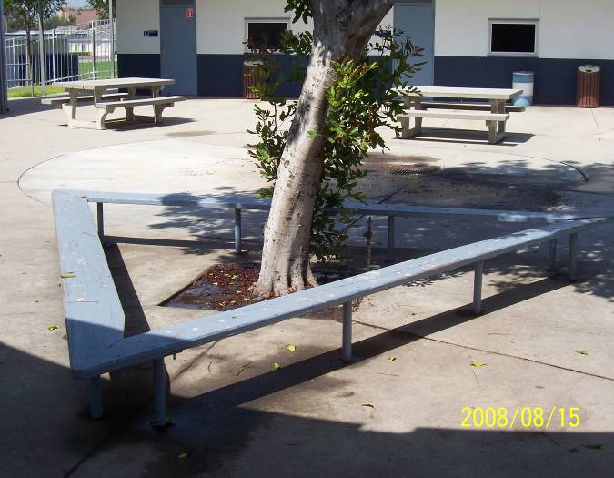 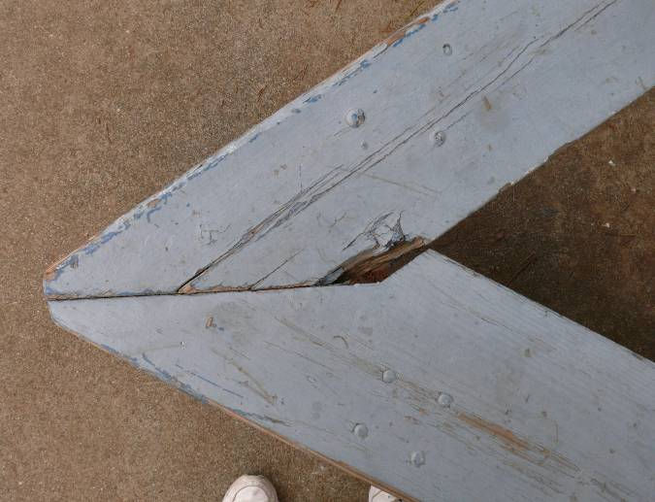**

**Bench Area B**

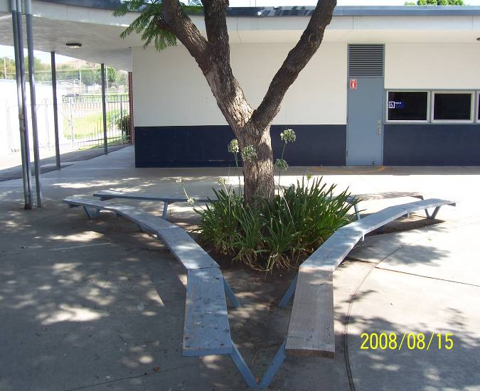

**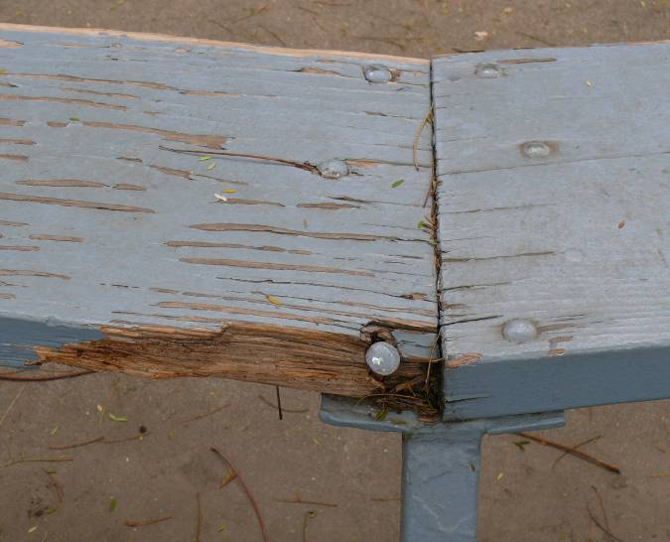**

**Area behind Classroom #21**

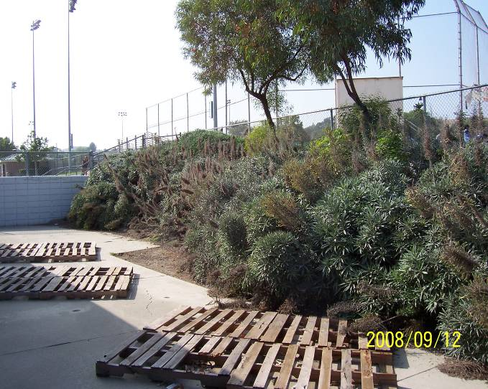 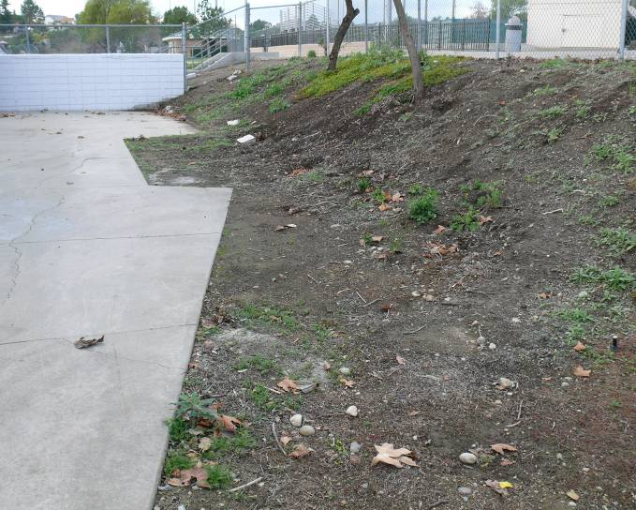

**Approval Signatures for Project Plan**

Project plans were reviewed and approved by:

|  |  |
| --- | --- |
| Religious institution, school, or community representative Date | Scoutmaster/Coach/Advisor Date |
| Unit committee member Date | Council or district advancement committee member Date |

|  |
| --- |
| **Important Note:** You may proceed with your leadership service project only when you have:  Completed all the above mentioned planning details  Shared the project plans with the appropriate persons  Obtained approval from the appropriate persons |

**Carrying Out the Project**

Record the progress of your project. Keep a record of how much time you spend planning and carrying out the project. List who besides yourself worked on the project, the days they worked, the number of hours they worked each day, and the total length of time others assisted on the project.

If appropriate, list the type and cost of any materials required to complete the project. If your original project plan changes at any time, be sure to document what the change was and the reason for the change.

**Hours I Spent Working on the Project**

The length of time spent should be as adequate as is necessary for you to demonstrate your leadership of two or more individuals in planning and carrying out your project.

Hours I spent:

|  |  |
| --- | --- |
| Planning the project: |  |
| Carrying out the project: |  |
| Total hours I spent working on the project: |  |

**Hours Spent by Scouts, Venturers, or Other Individuals Working on the Project**

**Project site: Suzanne Middle School, Walnut, CA Date: \_\_\_\_\_\_\_\_\_\_\_\_\_\_\_**

|  |  |  |  |
| --- | --- | --- | --- |
| **Name** | **Check in time** | **Check out time** | **No. of Hours** |
|  |  |  |  |
|  |  |  |  |
|  |  |  |  |
|  |  |  |  |
|  |  |  |  |
|  |  |  |  |
|  |  |  |  |
|  |  |  |  |
|  |  |  |  |
|  |  |  |  |
|  |  |  |  |
|  |  |  |  |
|  |  |  |  |
|  |  |  |  |
|  |  |  |  |
|  |  |  |  |
|  |  |  |  |
|  |  |  |  |
|  |  |  |  |
|  |  |  |  |
|  |  |  |  |
|  |  |  |  |
|  |  |  |  |
|  |  |  |  |
|  |  |  |  |

Total number of hours others worked on the project: \_\_\_\_\_\_\_\_\_\_\_\_\_

For a grand total, add the total number of hours you spent on the project to the total number of hours others worked on the project: \_\_\_\_\_\_\_\_\_\_\_\_\_\_

**Changes**

List any changes made to the original project plan and explain why those changes were made.

|  |
| --- |
| ***(This box may be adjusted to fit your description.)*** |

**“After” Photographs**

Including photographs of your completed project (along with the “before” photographs) helps present a clearer overall understanding of your effort.

**Approvals for Completed Project**

Start date of project: Completion date of project :

The project was started and has been completed since I received the Life Scout rank, and is respectfully submitted for consideration.

|  |  |
| --- | --- |
| Applicant's signature | Date |

This project was planned, developed, and carried out by the candidate.

|  |  |
| --- | --- |
| Signature of Scoutmaster/Coach/Advisor | Date |
| Signature of the representative of religious institution, school, or community | Date |